PART A
(Part A: TO BE REFERRED BY STUDENT S)
Experiment No. 09
A.1 AIM:
To study and understand Transaction Control Language (TCL) using commands like Commit, Rollback and create save point and use it with Rollback.
To study Data Control Language (DCL) using commands like GRANT and REVOKE
A.2 Pre requisite:
DML commands of SQL, concept of transaction and DCL .
A.3 Outcome:
After successful completion of this experiment students will be able to

- Understand the importance of transaction control commands in database management systems.
- Create the multiple users and grant some privileges as per their requirements and revoke permission from the ussers.

A.4 Theory:
Transaction:
A transaction is a logical unit of work that contains one or more SQL statements. A transaction is an atomic unit. The effects of all the SQL statements in a transaction can be either all committed (applied to the database) or all rolled back (undo from the database).
A transaction begins with the first executable SQL statement. A transaction ends when it is committed or rolled back, either explicitly with a COMMIT or ROLLBACK statement or implicitly when a DDL statement is issued.

There are following commands used to control transactions:

COMMIT: to save the changes permanently.

ROLLBACK: to roll back the changes.

SAVEPOINT: creates points (or bookmark) within groups of transactions in which to ROLLBACK SET

TRANSACTION: Places a name on a transaction.
Transactional control commands are only used with the DML commands INSERT, UPDATE and DELETE only. They cannot be used while creating tables or dropping them because these operations are automatically committed in the database.
- COMMIT Command:
The COMMIT command is the transaction control command used to save changes invoked by a transaction to the database.
The COMMIT command saves all transactions to the database since the last COMMIT or ROLLBACK command.
Syntax for commit command:
commit;
Example:
SQL> COMMIT;
SQL> DELETE FROM CUSTOMERS WHERE AGE = 25;
- The Rollback command:
The ROLLBACK command is the transactional command used to undo transactions that have not already been saved to the database.
The ROLLBACK command can only be used to undo transactions since the last COMMIT or ROLLBACK command was issued.
The syntax for Roll back command:
ROLLBACK;
For example
SQL> ROLLBACK;
SQL> DELETE FROM CUSTOMERS WHERE AGE = 25;

- The Savepoint Command:
A SAVEPOINT is a point in a transaction when you can roll the transaction back to a certain point without rolling back the entire transaction.
The syntax for SAVEPOINT command is as follows:
SAVEPOINT SAVEPOINT_NAME;
This command serves only in the creation of a SAVEPOINT among transactional statements. The ROLLBACK command is used to undo a group of transactions.
The syntax for rolling back to a SAVEPOINT is as follows:
ROLLBACK TO SAVEPOINT_NAME;
Example:
SQL> SAVEPOINT SP1;
Savepoint created.
SQL> DELETE FROM CUSTOMERS WHERE ID=1;
1 row deleted.
SQL> SAVEPOINT SP2;

Savepoint created.
SQL> ROLLBACK TO SP2;
Rollback complete.
SQL> DELETE FROM CUSTOMERS WHERE ID=2;
- row deleted.
SQL> SAVEPOINT SP3;
Savepoint created.
SQL> DELETE FROM CUSTOMERS WHERE ID=3;
1 row deleted.

SQL> select * from table_name;
Deleted records of ID=2 and ID=3 will be rollbacked.

DCL (Data Control Language)
DCL includes commands such as GRANT and REVOKE which mainly deal with the rights, permissions, and other controls of the database system.
List of DCL commands:
GRANT: This command gives users access privileges to the database.
REVOKE: This command withdraws the user’s access privileges given by using the GRANT
Syntax with descriptions:
, UPDATE ON MY_TABLE FROM USER1, USER2;
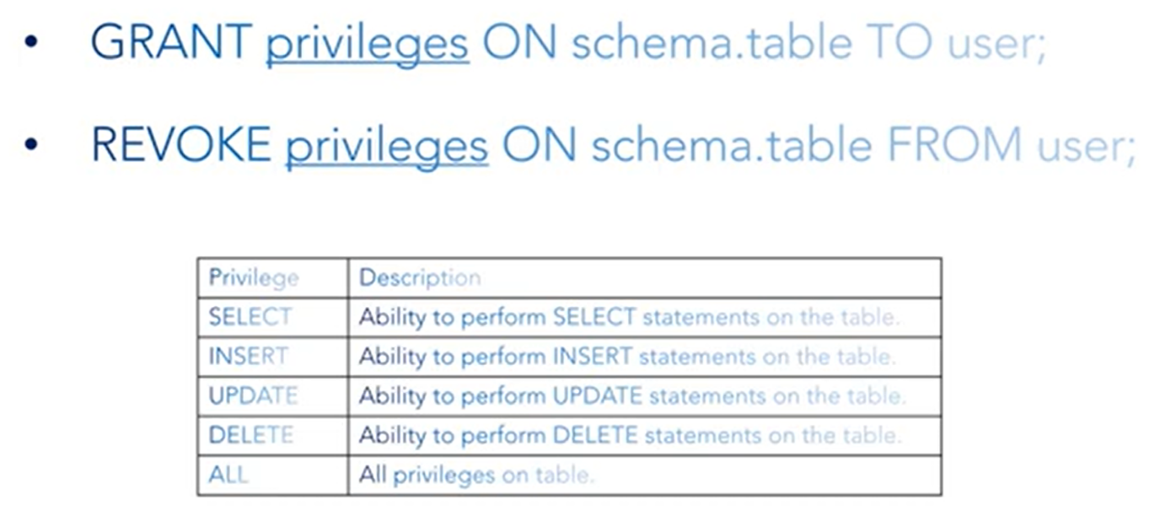
PART B
(PART B: TO BE COMPLETED BY STUDENTS)
(Students must submit the soft copy as per following segments within two hours of the practical. The soft copy must be uploaded on the Blackboard or emailed to the concerned lab in charge faculties at the end of the practical in case the there is no Black board access available)
Roll No. : | Name:
Class : | Batch :
Date of Experiment : | Date/Time of Submission :
Grade :

B.1 Tasks given in PART A to be completed here
(Paste your answers and output here)

B.2 Conclusion:
(Students must write the observations and learning based on their understanding built about the subject matter and inferences drawn)

B.3 Question of Curiosity
(To be answered by student based on the practical performed and learning/observations)
1. What is transaction?
2. What is rollback and commit command? Explain with an example.
3. What was your observation about savepoint command? Explain with an example?
4. Discuss the roll of DCL commands in multiuser environment

